**An Ultrasonic Sensor-based blind stick analysis with instant accident alert for Blind People**

***Abstract:***

The project is about the blind people who can't move without a stick, so we thought of doing a smart stick for blind people which can sense the obstacles and make buzzer sounds so he can move forward with that, in addition to that, we add fire and water sensors it beeps with different intensities to get attention from it. we can use ultrasonic sensors for a variety of obstacles like a pit, wall, drainages, vehicles, people etc . whenever he forgot the stick through his mobile phone with an app on the home screen can speak to it and the stick responds through voice output like 'you forgot me here' with the help of Bluetooth connection. Apart from these things, there may be chances to meet with an accident then we connected vibrate sensor with certain intensity more than usual . If in case the vibrator sensor senses the accident level frequency we set before then it sends msg to relatives through GPS and GSM connected to the Arduino board.

**Key words:** Ultrasonic sensor, Blind, GPS, GSM.

**I. INTRODUCTION**

International Agency for the Prevention of Blindness (IAPB) and WHO researchers found that there were 285 million visually impaired people in the world, of which 39 million were completely blind. More than 90% of the data comes from sub-Saharan Africa and other developing countries. One million Egyptians are blind, with 14% of them being children. According to the WHO and IAPB, the number of people who are blind worldwide is expected to double by 2020.

Blind people have a hard time moving or living on their own. Consequently, they frequently employ a white cane to serve as a moving guide. Despite the possibility that it could be beneficial, there is no guarantee that it will protect blind people from harm. Using these traditional methods is only suitable for detecting low-level obstacles.

**1.1. Assistive Technology**

Disabled people rely on assistive technology to help them carry out everyday tasks, make their lives easier, and keep them safe while they are out and about. Personal care, navigation and orientation, and mobility assistance were all developed in the 1960s to assist people in their daily lives.

Electronic devices that use sensors to help the visually impaired locate and identify objects in their immediate surroundings have made this assistive technology available to the blind. The sensors can help with mobility tasks by determining the object's dimensions, range, and height. Vision replacement is more difficult to categorise because it involves both medical and technological aspects. An ocular nerve or direct display to the brain's visual cortex can be used to replace vision [9-12]. Vision enhancement differs from "vision substitution" in that the camera input is processed and the results are visually displayed. A non-visual display that is easily controlled and felt by the blind user and is based on their hearing and touch senses results from vision substitution rather than vision enhancement [13].

An assistive solution is needed to assist visually impaired people in their daily activities, making their lives easier, safer, and more independent. It's been a long time coming, but researchers have been working on this kind of solution for a long time now [14]. In this section, only a few of these devices have been discussed in greater detail, and those devices are shown in Fig. 1 in a hierarchical order.

**1.2 Issues and Challenges**

Those who are sighted can gain a better understanding of what a visually impaired person has to deal with on a day-to-day basis by becoming familiar with the challenges and issues they face.

**Environmental Challenges**

The environment can be a difficult place to navigate for those who are blind or partially sighted [15]. It is even more difficult for them to travel in crowded places such as markets, train stations, and so on. As a result, blind people turn to assistive technology or members of their own family for assistance.

**Social Challenges**

People who are visually impaired may have an inferiority complex because they are unable to participate in some social activities like sighted people. As a result, they have a hard time playing outdoor games like volleyball.

**Technological Challenges**

While using the internet for research, recreation, shopping, etc., blind people encounter difficulties. The web pages are difficult for the visually impaired to read. Despite the fact that a number of devices have been developed for this purpose, it isn't as common among all ages of blind people.

**Others**

Many aspects of daily life are difficult for people who are blind, and they often feel different from those who are sighted. Blind people face a slew of additional difficulties, such as completing household tasks, donning make-up, recognising different denominations of currency, navigating unfamiliar terrain, and crossing a road.

**1.3 Research Problem**

People with visual impairments can benefit from new technologies that are on the horizon. In terms of the development and implementation of assistive devices for people with visual impairments, however, there has been little progress.

Obstruction detectors using vision-based sensors, ultrasonic sensors, and infrared sensors, as well as fusions of multiple sensors, are the subject of numerous research projects at the moment. Vision-based systems may be more accurate than other non-vision-based systems, but they require more computational power to operate in real time. An ultrasonic sensor, for example, is a low-cost and computationally light alternative to a vision-based sensing system.

There aren't any commercially available, low-cost wearable detectors that don't rely on vision and can be used both indoors and outdoors. This could be due to the large number of conceptual models and prototypes that were abandoned during the experimental stage without being evaluated for their usability and performance.

**1.4 Objectives**

Research objectives include developing an obstacle detection model for the visually impaired that does not rely on vision.

1. The limitations of current non-vision-based obstacle detection systems for the blind should be examined.
2. Non-vision obstacle detection that is inexpensive, low-power, light-weight and unobtrusive for the visually impaired is the second objective of this research.
3. To test the proposed non-vision obstacle detection system

**II. RELATED WORK**

**Visual Impairment**

Visual acuity is a term used to describe an individual's ability to see clearly. An individual's visual acuity can be assessed using the Snellen eye chart, which is depicted in Figure 2.1. (Segre 2017). Fractions of two numbers represent the measurement. Individuals will see the numerator from a certain distance. A person of average vision can see what is specified as a denominator at a given distance. If a person has 6/6 vision, they are capable of seeing everything at a distance of 6 metres. People with normal vision can see 60 metres away at a distance of 6 metres, but those with poor vision must be at least 6 metres away to do so. In the United States, visual acuity is measured in feet, so someone with 20/20 vision can see clearly at a distance of 20 feet (60 metres in SI units). A person's visual field refers to the total area or range of vision they have.

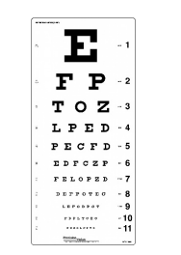

Figure 2.1: Snellen Chart

When it comes to the blinds, M Narendran, 2018, developed wearable technology. This device's main selling point is its reasonable price. Arduino Pro Mini 328-15/16 MHz is worn like a piece of technology. An ultrasonic sensor module was included in this. Visible-impaired individuals can get around more easily thanks to this sensor. You'll get an audible beep or vibrating sensation if the sensor detects an object. Wearable band, buzzer, blind, people, ultrasonic.

The proposed system includes an ultrasonic sensor, a water sensor, a voice playback board, a raspberry pi, and speakers. A camera is used in the proposed system to detect images of obstacles both indoors and out. Using an ultrasonic sensor, a smart walking stick measures the distance between the object and the stick. Consider and process the image ahead of time in order to give the user a clear picture of what they're looking at. Image processing compares the images sent from the camera to the images stored in the dataset. For image processing, morphology segmentation is employed.

The different sensors like object sensors (ultrasonic sensors), humidity sensor, temperature sensor and light sensor are used. Speaker and volume control is used in the form the status to the blind people. GPS is used to track the blind people path and emergency conditions are transmitted to the neighbour through GSM based alarm system. This project is implemented by using the DSPIC30F2010 controller ,ARM Processor,DISPIC3OF 2010.

The ultrasonic sensors and Arduino are used in this paper to demonstrate a smart walking stick for people who are blind or visually impaired. Programming in c language was used to design the system, which was then tested by a visually impaired person to ensure it was accurate. Our device is capable of detecting obstacles as close as 2 metres away from the user. Arduino microcontroller, ultrasonic sensor, mobility aid, visually impaired individual, alarm.

An obstacle detecting cane developed by Mutiara, Hapsari, and Rijalul (2016) uses ultrasonic sensors to detect holes and provide a qibla direction through an audio feedback system. There are sensors on the cane's base. Activating the ultrasonic obstacle detection mode or the compass qibla direction mode is done by pressing a single button. Figures 2.2 and 2.3 show that despite the cane's foldability, it has wires running around it that could cause electronic malfunctions if the wires were to be disconnected. Hitches and holes were all the prototype could detect. There were six people who used the prototype to test its ability to detect and alert them to hitches and holes on the path. Prototypes were difficult to use for four of the six participants who tried them out.

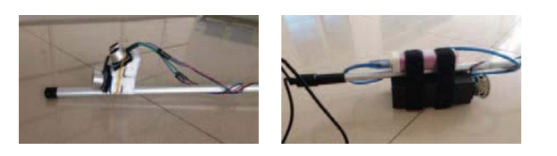

Figure 2.2: Placement of sensor (left), microcontroller and energy storage system (right)

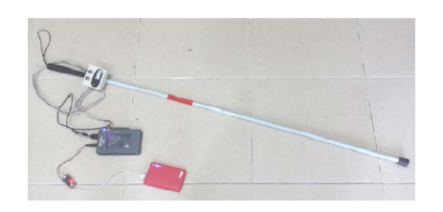

Figure 2.3: Prototype of smart cane using audio cue

**III. METHODOLOGY**

This section discusses the design and implementation of a blind-friendly walking stick, as well as the theory behind some of its components. After a signal is generated by the ultrasonic sensor transmitter, it is reflected back from an obstacle and received by an ultrasonic sensor receiver. This signals the microcontroller to atrigger/switch ON a buzzer.

**3.1 Proposed System**

Ultrasonic sensors are used in our design, and the microcontroller is connected to them via an Arduino sketch, as well as the physical sensors themselves. Arduino UNO employs the ATmega328p microcontroller board (datasheet). The board comes with 14 digital output and input pins, six of which can be used as PMW outputs, six analogue inputs, a USB connection, a power jack, and an ICSP reset button. Moisture sensors use two wires to detect the presence of water, relying on the specific resistance of water. Arduino sketches were used to programme the RF transmitter and RF receiver, which were then connected to the microcontroller. The LCD was connected to a pin on the microcontroller, and the Arduino sketch was used to write all of the code. This new system will allow the visually impaired to get where they need to go on their own. In addition, it is very user-friendly and straightforward. When mass-produced for people who are visually impaired, it will be accessible to a broader demographic. In both indoor and outdoor navigation modes, the system is able to detect obstacles. Using a pair of ultrasonic sensors, the smart stick in figure 3.1 is able to detect obstacles in the blind's path from ground level to head level, in the 400 cm a head range. The microcontroller receives data in real time from ultrasonic and water sensors. The buzzer goes off after the microcontroller processes this information. Circuits are powered by a battery that is powered by the water sensor.

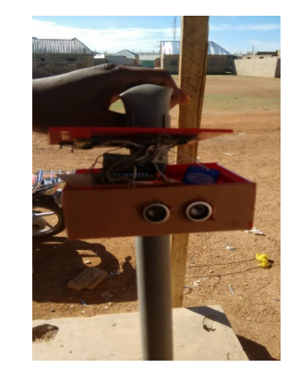

Fig. 3.1: A working ARDUINO smart blind stick.

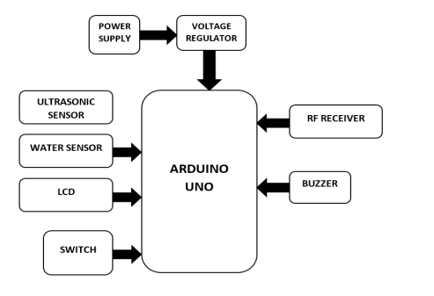

Fig. 3.2: The proposed system's block diagram.

A block diagram depicting the various components used in the design and implementation of the smart stick has been created.

**3.2 Working of the system**

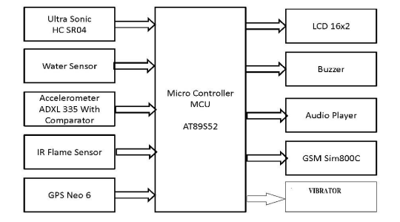

Figure 3.3: block diagram

The 5-volt DC supply is given to microcontroller AT89S52 and all the sensor for supply voltage. The input components of microcontroller is ultrasonic sensor, water sensor, accelerometer, IR flame sensor, GPS neo6 and output components of microcontroller is LCD 16 x2 display, Buzzer, Audio Player and GSM 800C, Vibrator. The microcontroller are provided the instructions through program. Then the input sensors sense and the logic is provided to microcontroller, then microcontroller will send the output from according to desired program to output components, which is LCD display, audio player, buzzer, vibrator gsm sim.

**3.2.1 At89s52 Microcontroller**

Microcontroller AT89S52 is an 8-bit microcontroller with 8000 bytes of non-volatile storage. The Atmel at89s52 may be a powerful microcontroller with an on-chip flash and a monolithic side chip with a programmable flash. 8kbyte flash memory, 32 I/O lines (watchdog timer), 2 knowledge pointers (three 16-bit timer/counters), a 6-vector 2-level interrupt design, a full duplex interface, an on-chip generator and clock electronic equipment are included in the at89s52prf. At89s52 also has two different power-saving modes and a static logic design for use at zero frequencies.

**3.2.2 Ultrasonic Sensor**

Measurement of distances between the sensor and the object is the primary use of ultrasonic devices. The Doppler Effect is the basis for the ultrasonic device. They include an ultrasonic transmitter and a receiver. Signals are transmitted in only one direction by the transmitter. The obstacle then reflects this signal back to the receiver, allowing the receiver to receive the transmitted data. The entire time it takes for the signal to be transmitted and received back is used to calculate the distance between the supersonic vehicle and the obstacle.

**3.2.3 Accelerometer (ADXL335)**

It is a three-axis accelerometer with a very small, thin, low-power signal condition voltage output that is used in mobile devices. There is a minimum acceleration range of 3 g. There are two types of static acceleration that tilt sensors measure: the acceleration due to gravity's pull and the acceleration caused by motion.

**3.2.4 Infrared Sensors**

Horizontal and inclining infrared sensors are used in the system we have developed. Figure 3.4 shows the area ahead of the blind being scanned by two horizontal IR sensors, one at a height of 90 cm and the other at a height of 75 cm.

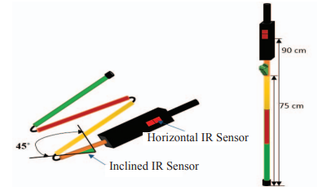

Fig.3.4. Design of smart stick

The transmitter sends out a pulse of IR signal, and the signal travels through the environment in response to this pulse. This means that in the absence of an obstruction, the signal is never received by the receiver and thus there is no reflected signal. However, the receiver still receives a very weak noise signal from its surroundings. The signal is reflected as soon as an obstruction is detected.

**3.2.5 GSM Modem**

In our model we tend to use GSM for sending and receiving information using text message, since GSM is associated with open, digital cellular technology used for sending mobile voice and knowledge, we have got placed. This module within the stick, once the visually handicapped person pulse has a below a threshold price then victimization this module text messages are communicated to his friend.

**3.2.6 Gps Neo6**

The NEO-6 module series, which could be a family of complete GPS receivers, includes the u-box vi positioning engine. A wide range of memory properties makes NEO-6 modules ideal for battery-powered mobile devices with extremely limited price and space constraints.

**3.2.7 Vibrator**

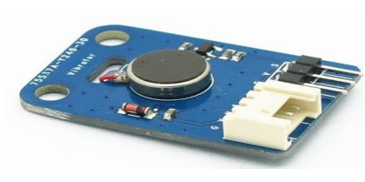

Figure 3.5: vibrator

This is a vibrator brick appropriate as a non-audible indicator. Once the input is high, the motor can vibrate a bit like your telephone on silent mode.

**3.2.8 Buzzer**

Apply 3V to 5V to the current buzzer module and you will be rewarded with a loud 2 KHz BEEP. Not like an apparent piezo, this buzzer doesn't would like associate degree AC signal. within may be a piezo part and the motive force electronic equipment that produces it oscillate at 2KHz. The buzzer is 5V TTL logic compatible and bread board friendly pin spacing.

**3.2.9 Audio Player**

Audio Player Is Nothing But A Speaker, Which Is Connected At The Output Of The System For Announcement Purpose. As Per the System Application, According to The Visual Based Guide, The Respective Saved Audio File is Played Using A Speaker.

**IV. RESULTS AND DISCUSSIION**

The efficacy of our proposed procedure was put to the test through a series of experiments. Figure 4.1 shows a screenshot of a working ultrasound sensor simulation.

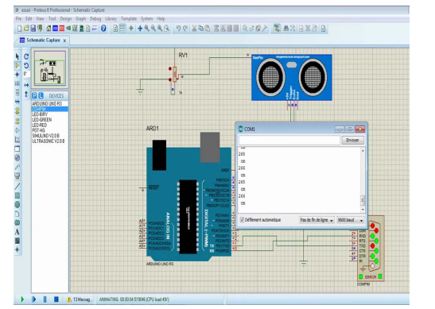

Fig 4.1: The simulation of a working ultrasonic sensor

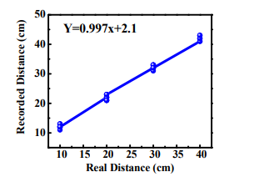

Figure 4.2. Comparison of distance between real value and recorded value

Our lab and campus were used to test the system's ability to detect obstacles. Ultrasonic sensors were found to be accurate in detecting obstacles, and the distance to the obstacles was also found to be accurate. Figure 4.2 depicts the relationship between the recorded and actual distances, which was used to compare the calculated distance to the actual distance.

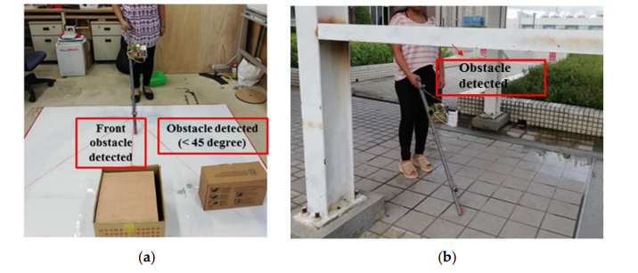

Figure 4.3. Experimental result of obstacle detection: (a) Indoor testing; (b) outdoor testing

There is a 45-degree angle of detection for the SRF08 ultrasonic range finder, according to its datasheet. Experimenting with the beam pattern of the SRF08 ultrasonic sensor found that it could detect the front obstacle, as well as between a 45-degree conical shape and 30 to 40 centimetres from ground level. Second ultrasonic sensor was able to detect obstacles at a height of 130 to 140 centimetres. An iron bar embedded in a side wall that appeared to be empty from the ground, but from a certain height it had an iron bar, was detected by the second ultrasonic sensor in Figure 4.3b.

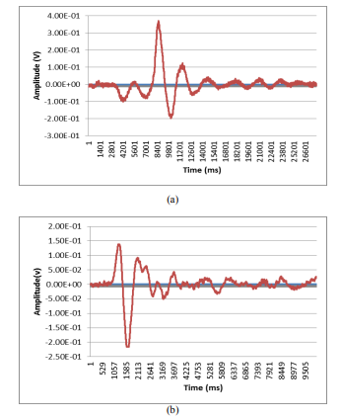

Fig. 4.4. Infrared sensor-received signal (a) stair-up signal (b) stair-down signal.

Second experiment was a real-world testing outside and inside buildings; first experiment was a lab validation of the results. The oscilloscope is connected to the output of the inclined sensor in the lab valid test to observe the variation in the received signal. Figures 4.4a and 4.4b show that when stairs are present, a signal is received that is different in shape and amplitude from the transmitted signal.

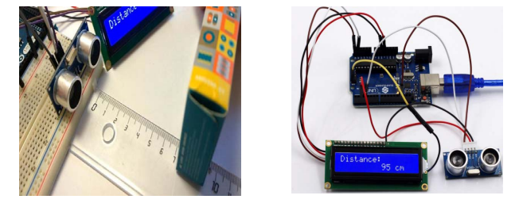

Fig. 4.5: Distance Measurement with the Circuit.

Due to the fact that ultrasonic sensors operate on the echo principle, it is critical to examine how different obstacles reflect the echoes. Sensor trigger pin (T1) is first pulsed by the microcontroller for 10s, followed by an ultrasonic signal with 40 kHz and 450s sent out by the sensor (T2) and the rising edge output by echo port (T3) from 150s: 25mS, depending on measured distance as shown in figure 4.5. The rising edge output is then captured by echo port (T3).

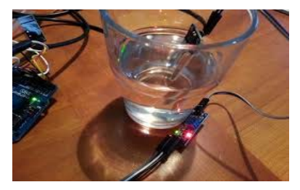

Fig. 4.6: Water Detection by the System

The circuit was put together on a bread-board. On the table was set a container filled with water. When the moisture sensor was submerged in the water, it made a different kind of beep sound than the one made by the obstacle sensor. The transistors in the walking stick will activate the alarm system whenever it is inserted into water that is at least 3 feet deep. Figure 4 shows the results of our moisture test.

**CONCLUSION**

The primary goal of this research was to develop and implement a smart walking stick for the blind.. The Smart Stick is the foundation for the next generation of assistive devices for the visually impaired. It's both efficient and economical at the same time. Obstacles that lie within a three-meter path of the user can be detected with reasonable accuracy by this device. This system's quick response time and low power consumption make it a great value for the money. Light in weight, despite the system being hardwired with sensors and other components. By using microcontroller and other small sensors, the hardware implementation is very cost effective. Size of model is very compact so the stick is very comfortable to carry along. By the application of voice playback module in any language instructions can give so these stick we will use worldwide. The main function of our model is sending emergency message to the take careers of blind person within 2 minutes and also location which is effectively done by the application of GSM and GPS module.

**REFERENCES**

1. M Narendran, SarmisthaPadhi, Aashita Tiwari, “the third eye for the blind using Arduino and ultrasonic sensor”. Department of Computer Science & Engineering, SRM Institute of Science & Technology Ramapuram, Chennai, Tamil Nadu, India ,National Journal of Multidisciplinary Research and Development ISSN: 2455-9040 Volume 3; Issue 1; January 2018; Page No. 752-756 .
2. Sathya, S.Nithyaroopa, P.Betty, G.Santhoshni, S.Sabharinath, M.J.Ahanaa”smart walking stick for blind person”. Department of Computer Science and Engineering, Kumara guru College of Technology Coimbatore. Coimbatore International Journal of Pure and Applied Mathematics Volume 118 No. 20 2018, 4531-4536.
3. Jayakumar, S.Magesh ,K.Prasanth, P.Umamaheswari, R.Senthilkumar,”smart walking stick for visually impaired people”. Dept.of EEE, Erode Sengunthar Engineering College. International Journal of Advanced Research in Basic Engineering Sciences and Technology (IJARBEST) Vol.3, Special Issue.24, March 2017.
4. Dada Emmanuel,Gbenga, Arhyel, Ibrahim Shani , Adebimpe Lateef, Adekunle . “Smart walking stick for visually impaired people using ultrasonic sensor and Arduino”.Department Of Computer Engineering, University Of Maiduguri, Borno State, Nigeria . International journal of innovative research in electrical, electronics, instrumentation and control engineering vol. 4, issue 3, March 2016.
5. Mutiara, GA, Hapsari, GI & Rijalul, R 2016, 'Smart guide extension for blind cane,' 2016 4th International Conference on Information and Communication Technology (ICoICT), 1-6.
6. Elmannai, W.; Elleithy, K. Sensor-based assistive devices for visually impaired people: Current status, challenges, and future directions. Sensors 2017, 17, 565. [CrossRef] [PubMed]
7. Dhod, R.; Singh, G.; Singh, G.; Kaur, M. Low cost GPS and GSM based navigational aid for visually impaired people. In Wireless Personal Communications; Springer: New York, NY, USA, 2017; Volume 92, pp. 1575–1589.
8. Bharambe, S.; Thakker, R.; Patil, H.; Bhurchandi, K.M. Substitute Eyes for Blind with Navigator Using Android. In Proceedings of the India Educators Conference (TIIEC), Bangalore, India, 4–6 April 2013; pp. 38–43.
9. Sangami, A.; Kavithra, M.; Rubina, K.; Sivaprakasam, S. Obstacle detection and location finding for blind people. Int. J. Innov. Res. Comput. Commun. Eng. 2015, 3, 119–123.
10. Swain, K.B.; Patnaik, R.K.; Pal, S.; Raja, R.; Mishra, A.; Dash, C. Arduino based automated stick guide for a visually impaired person. In Proceedings of the 2017 IEEE International Conference on Smart Technologies and Management for Computing, Communication, Controls, Energy and Materials (ICSTM), Chennai, India, 2–4 August 2017; pp. 407–410.
11. Ramadhan, A.J. Wearable smart system for visually impaired people. Sensors 2018, 18, 843. [CrossRef] [PubMed]
12. Morad, A.H. GPS talking for blind people. J. Emerg. Technol. Web Intell. 2010, 2, 239–243. [CrossRef]
13. Kher Chaitrali, S.; Dabhade Yogita, A.; Kadam Snehal, K.; Dhamdhere Swati, D.; Deshpande Aarti, V. An intelligent walking stick for the blind. Int. J. Eng. Res. Gen. Sci. 2015, 3, 1057–1062.
14. Arduino vs Raspberry Pi vs BeagleBone vs PCDuino. Available online: https://randomnerdtutorials.com/ arduino-vs-raspberry-pi-vs-beaglebone-vs-pcduino/ (accessed on 14 December 2018).
15. Arduino vs. Raspberry Pi. Available online: https://circuitdigest.com/article/arduino-vs-raspberryp-pidifference-between-the-two (accessed on 14 December 2018). 20. Leccese, F.; Cagnetti, M.; Trinca, D. A smart city application: A fully controlled street lighting isle based on Raspberry-Pi card, a ZigBee sensor network and WiMAX. Sensors 2014, 14, 24408–24424.